CHRISTMAS AND NEW YEAR ORDER FORM
LAST ORDERS BY 10TH DECEMBER 2020

Name
Address | Local delivery available – please ask for further information.
Email | Please note that acknowledgement of orders will be sent to this email address.
Telephone
Opening Hours
Christmas Opening Hours  Please note that we are open 7 days a week from 8am until 6pm, with the exception of the days as shown here.  Our vending machine will operate 7am until 9pm every day. |  |  |  | Christmas Eve – 8am until 4pm  Christmas Day and Boxing Day – Closed, except for the vending machine.  Emergency number ONLY 07900 814252.  27th December – 8am until 4pm – shop, coffee, and light bites  28th December – normal hours resume for shop and café  New Year’s Eve – 8am until 4pm  New Year’s Day – 8am until 4pm
Christmas order collections – please tick as appropriate
Tuesday 22nd December |  | Wednesday 23rd December |  |  |  |  | Thursday24th December
10pm – 6pm |  | 8am – 6pm |  |  |  |  | 8am – 4pm
collections for pre-orders only – WYKEN VINEYARD
Wyken Vineyard
Saturday 19th December 9am – 1pm |  |  |  |  | Thursday 24th December 8am – 10am
New Year’s Eve Order collections – please tick as appropriate
Tuesday 29th December |  | Wednesday 30th December |  |  |  |  | Thursday 31st December
12pm – 5pm |  | 8am – 6pm |  |  |  |  | 8am - 5pm
Total |  |  |  |  |  | £
Dairy
Cheese
Deli
Special Christmas Butchery Hampers
Butchery – Pork
Butchery – Beef
Butchery – Lamb
Butchery – Chicken
Butchery – Game
Godwick Hall - Turkey
Darrow Green – Turkey
Morton’s – Turkey
Wine – Old Hall Vineyard
Wine – Humbleyard
Wine – Flint
Wine – Chet and Waveney
Hamper - Old Hall Farm
Hamper – Cheese
Hamper – Hamper for Santa
Hamper – The Gin Lover’s
Hamper – Honey Lover’s
Hamper - Christmas Eve
Hamper – Boxing Day Brunch
Staff Initials |  |  | Total
Date received |  |  | Balance Due on collection excluding 25% deposit
Dairy Produce
Item |  | Sizes Available |  |  |  |  | Quantity
Milk will be available to buy in the shop every day as normal in 0.5L, 1L and 2L bottles. The vending machine will be stocked when the shop is closed.
Cream £12/L |  | 125ml, 250ml, 500ml, 1L  Please indicate glass (50p surcharge) or plastic
Yoghurt/Skyr |  | 250ml (£3), 500ml (£5)  Please indicate if you’d like plain, fruit, or honey version, and whether Skyr (skimmed) or Greek (full fat)
Butter (200g) |  | Please indicate whether  Salted or Unsalted (£4.50)
Fudge |  | £3.50 presented in glass jars with a seasonal ribbon
Ghee |  | 250ml (£8.50), 100ml (£4.50)
Ice Cream  Chocolate, Pure Jersey, Caramel, Strawberry, Coffee |  | 200ml (£3.50), 400ml (£6)
Cream Cheese (made to order) |  | £3.50/100g
Cheese  Our deli counter will be fully stocked over the festive period. Please note that prices may vary slightly and we will cut your cheeses as accurately as possible! |  |  |  |  |  |  | Quantity/Amount
White lady (Norfolk) – Sheep |  | £7.00/200g round
Ogleshield (Somerset) |  | £2.00/100g
Montgomery Cheddar (Somerset) |  | £2.00/100g
Colston Basset (Wiltshire) |  | £2.00/100g
Suffolk Blue (Suffolk) if available |  | £3.00/100g
Suffolk Gold |  | £3.00/100g
Binham Blue (Norfolk) |  | £2.60/100g
Gurney Gold (Norfolk) if available |  | £2.60/100g
Walsingham (Norfolk) |  | £2.20/100g
Wells Alpine (Norfolk) |  | £2.20/100g
Deopham Blewe (Norfolk) – Sheep |  | £2.75/100g
Copys Cloud (Norfolk) |  | £2.50/100g
Norfolk Mardler (Norfolk) |  | £3.00/100g
St Jude (Bungay) |  | £5.50 each
St Cera (Bungay) |  | £5.50 each
St Helena (Bungay) |  | £25/kg
Baron Bigod (Bungay) |  | £6.50/250g Baby Bigod  £3/100g  Whole 1kg Bigod £25
Truffled Baron Bigod |  | £12.50/250g Baby Truffled Bigod
Norfolk Tawny (Norfolk) |  | £2.30/100g
Norfolk Dapple (Norfolk) |  | £2.30/100g
Ruby Dapple (Norfolk) |  | £2.30/100g
Wensum White (Norfolk) |  | £7 each per round
Wissington (Norfolk) – Sheep |  | £2.70/100g
Stinking Bishop (Herefordshire) |  | £3.50/100g
May Hill Green (Herefordshire) |  | £3.50/100g
Lincolnshire Poacher (Lincolnshire) |  | £2.50/100g
Snowdonia cheeses  Black Bomber, Red Storm, Bouncing Berry, Pickle Power, Green Thunder, Amber Mist, Beechwood |  | £5.25 each
Wyke Farm Mature Cheddar |  | £12.00kg
Shropshire Blue |  | £2.00/100g
Wensleydale |  | £1.65/100g
Wensleydale and Apricot |  | £1.65/100g
White Stilton |  | £1.50/100g
Ethical Dairy Cheese (Scotland)
Rainton Tomme |  | £2.50/100g
Laganory |  | £2.50/100g
Fleet Valley Blue |  | £3.60/100g
Carrick |  | £3.00/100g
We will have a full range of other cheeses such as Mozzarella, Parmesan etc – please let us know if you would like anything kept aside for you
Deli Counter
Item |  | Size Available |  |  |  |  | Quantity
Sausage Roll (plain) |  | Large £10  Small £3.50
Sausage Roll (with red onion marmalade) |  | Large £10  Small £3.50
Scotch Eggs (Gluten Free) |  | £3.50
Vegetable Sausage Rolls |  | £3.50
Brays Cottage Hand raised pork pie  Onion marmalade, plain, black pudding, or Fig with a touch of orange zest |  | Small – 2.5 inch £3.50  Medium – 4.5 inch £8  Large - 7 inch £22.75
Sliced Cooked Ham |  | £12.95/kg
Ham hock terrine |  | £3.00/100g or larger terrines by arrangement
Homemade Quiches  Binham Blue and cranberry or cheese and ham |  | £6.50
Family size beef pie |  | £10
Whole cooked hams |  | POA
Old Hall Farm Salami or Chorizo, from our own rare breed pigs |  | Salami - £14.50 per 200g stick  Chorizo £9.50 per 200g stick
Goose Fat |  | £3.95
Stokes Cranberry Sauce |  | £4.25
Stokes Redcurrant Sauce |  | £4.25
Butchery Counter
Pork – Old Hall Farm rare breed pork
Item |  | Size/Cost |  |  |  |  | Quantity
Bacon – Smoked/Unsmoked Back |  | £14/kg
Bacon – Smoked/Unsmoked Streaky |  | £14/kg
Gammon Smoked/Unsmoked |  | £14/kg
Pork Joints  Belly  Shoulder  Leg  Loin |  | £10/kg
Traditional Sausages (GF) |  | £10/kg
Pork and Apple Sausages (GF) |  | £10/kg
Traditional Chipolatas (GF) |  | £10/kg
Traditional Sausage meat (GF) |  | £10/kg
Cocktail Sausages (GF) |  | £11/kg
Mini pigs in blankets (GF) |  | £15/kg
Large pigs in blankets (GF) |  | £15/kg
Tenderloin |  | £10/kg
Stuffing Tubes – sage and chestnut or red onion marmalade |  | £10/kg
Pork other |  | POA
Beef – minimum 28 day dry aged
Item |  |  | Size/Cost |  |  |  |  | Quantity
Topside |  |  | £18/kg
Rolled Rib |  |  | £30/kg
Fore Rib on the Bone |  |  | £30/kg
Sirloin Rolled |  |  | £28/kg
Sirloin Steaks |  |  | £25/kg
Rump Steaks |  |  | £20/kg
Fillet in the piece |  |  | £40/kg
Fillet Steaks |  |  | £40/kg
Diced Beef |  |  | £12/kg
Other Beef |  |  | POA
Lamb – Organic Lamb from Shimpling Park
Item |  |  | Size/Cost |  |  |  |  | Quantity
Leg Joint |  |  | £15/kg
Shoulder Joint |  |  | £15/kg
Chops |  |  | £15/kg
Fillet |  |  | £15/kg
Lamb Mince |  |  | £10/kg
Lamb other |  |  | POA
Chicken – Sutton Hoo Free Range Chicken
Item |  |  | Size/Cost |  |  |  |  | Quantity
Whole Chicken |  |  | £8.50/kg
Chicken thigh/breast/wing/drumsticks |  |  | £10-12.50/kg
Game
Item |  |  | Size/Cost |  |  |  |  | Quantity
Venison roasting joint |  |  | £16/kg
Venison Loin |  |  | £16/kg
Venison Diced |  |  | £16/kg
Venison Steaks |  |  | £16/kg
Venison Sausages |  |  | £16/kg
Pheasant |  |  | £4
Pheasant Breasts (500g pack) |  |  | £8/kg
Rabbit Whole |  |  | £6
Rabbit Backs |  |  | £8/kg
Rabbit Dice |  |  | £8/kg
Partridge |  |  | £3.25 |  |  |  |  | `
Game Other |  |  | POA
Black/White Pudding (Fruit Pig) |  |  | £5.50
Haggis (Fruit Pig) |  |  | £5.50
Special Christmas Hampers
Up to 6 people £170
Locally grown Norfolk Turkey approx. 5kg, OHF pigs in blanket x 24, OHF sausage meat and stuffing, OHF topside/silverside approx. 1.5kg and OHF Smoked Gammon joint approx. 1.5kg
Up to 4 people £140
Locally grown Norfolk Turkey crown approx. 3kg, OHF pigs in blanket x 12, OHF sausage meat and stuffing, OHF topside/silverside approx. 1kg and OHF Smoked Gammon joint approx. 1kg
Up to 2 people £85
Locally grown Norfolk Turkey breast approx. 3kg, OHF pigs in blanket x 8, OHF sausage meat and stuffing, OHF topside/silverside approx. 800g and OHF Smoked Gammon joint approx.800g

Turkey Sizing Guide
Pounds | KG approx. |  | Serves approx. | Pounds |  | KG approx | Serves approx.
10 | 4.5 |  | 4 to 5 | 19 |  | 8.5 | 14
11 | 5 |  | 6 | 20 |  | 9 | 15
12 | 5.5 |  | 7 | 21 |  | 9.5 | 16
13 | 6 |  | 8 | 22 |  | 10 | 17
14 | 6.5 |  | 9 | 23 |  | 10.5 | 18
15 | 7 |  | 10 | 24 |  | 11 | 19
16 | 7 |  | 11 | 25 |  | 11.5 | 20+
17 | 7.5 |  | 12
18 | 8 |  | 13
Norfolk Black Turkeys and Geese from Godwick Hall
4.5- 5kgs |  | £70
6 to 7kg |  | £75 - £91
7 to 9kg |  | £97 - £103
9kg + |  | £109
Turkey Crown 3+kg |  | £19.25/kg
Standard Breast Rolls |  | £20.35/kg
Geese 4.5kg – 6.5kg |  | £16.20/kg
Locally Sourced Bronze Turkeys from Darrow Green Farm
4+kg |  | £50
5+kg |  | £55
6+kg |  | £62
7+kg |  | £70
8+kg |  | £80
9+kg |  | £90
10+kg |  | £100
Crowns |  | £15/kg
Breast rolls/Butterflies |  | £16/kg
Locally Sourced Norfolk Bronze Turkeys from Morton’s
4+kg |  | £72
5+kg |  | £80
6+kg |  | £90
7+kg |  | £95
8+kg |  | £102
9+kg |  | £110
10+kg |  | £115 - £130
Stuffed Turkey Breast Supreme  Superb Morton’s turkey breast stuffed with rare breed pork, chestnuts and turkey thigh meat. Serves 4. |  | £39
Turkey Crowns 3+kg |  | £72
Turkey Crowns 4+kg |  | £82
Turkey Crowns 5+kg |  | £95
Turkey Breast Joints 1+kg |  | £28
Turkey Breast Joints 2+kg |  | £48
Turkey Breast Joints 3+kg |  | £65

Wine
Old Hall Vineyard | Price | Quantity
Sauvignon Blanc | £15.50/bottle  Case of 6 £90  Case of 12 £170
Sparkling White | £25
Sparkling Blush | £25
Humbleyard Vineyard
Solaris (Still White) | £14
Bacchus (Still white) | £14
Pearl Pink Rose (Still pink) | £14
Cabernet Cortis (Still red) | £14
The Pinots (Still red) | £14
Brut Rose (Sparkling pink) | £21.50
White Cuvee (Sparkling) | £21.50
Prestige Cuvee (Sparkling) | £28.00
Flint Vineyard
Bacchus (Still White) | £17
Silex Blanc (Still Red) | £19
Charmat (Sparkling Pink) | £22.00
Pinot Noir Precoce (Still Red) | £21.50
Chet and Waveney Valley Vineyard
Skylark | £21.50
Horatio (Sparkling) | £28
Redwing | £14
Swift | £14

Old Hall Farm Tea Towels  Frida Cowlo  Pablo Peckasso  Piggy Stardust  £9.50 each of set of 3 for £25 | 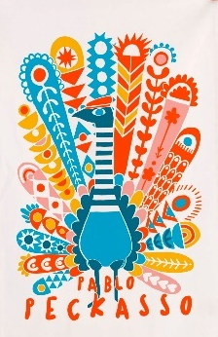
Old Hall Farm Tote Bags  £8 each or 2 for £15 | 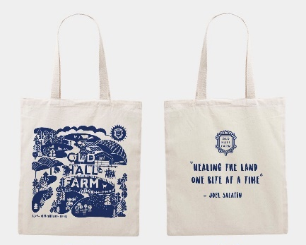  “Healing the Land”  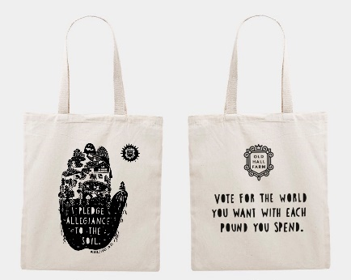  “I pledge allegiance to the soil”
Old Hall Farm Apron  A deep navy or charcoal grey apron with our classic OHF logo | £16.50
Hampers
Hampers can be created using all of our available produce – please do not hesitate to contact us for bespoke hamper creations. Discounts available for multiple and corporate orders. Delivery across the UK is available.
The Old Hall Farm Hamper – a selection of OHF produce to include milk, milkshakes, butter, ghee, fudge and rainbow eggs.  Add a bottle of Old Hall Farm Sauvignon Blanc | £35  £50
The Cheese Lover’s Hamper – a selection of our favourite cheeses, local chutney, sourdough, meddler jelly and OHF butter. | £35 (four cheese)  £50 (seven cheese)
Hamper for Santa  Wooden Festive board, 4 homemade mince pies, carrots and 4 mini milkshakes | £20
The Gin Lover’s Hamper  3 x St Giles Gin mini’s, Boudica Gin, Adnam’s Copperhouse chocolates, small Norfolk Gin, 2 x Tealady’s Gin jams, Norfolk Gin botanical pouch, lemon and lime. | £100
Christmas Eve Hamper  4 Chocolate Hot Shots, IL raw jersey milk, OHF fudge & 4 mini raw milkshakes | £20
The Honey Lovers Hamper – a selection of 5 different honeys from Norfolk apiaries and wildflower seed bombs. | £55
Boxing Day Brunch Hamper  Local baked sourdough, box of OHF eggs, 250g back bacon, 8 traditional pork sausages, fruit pig black pudding, mushrooms and tomatoes,  Norfolk teabags | £30
The “Best of Norfolk” Hamper  A selection of the very best of Norfolk produce, hand picked in line with your specifications | £50 to £250

Old Hall Farm Christmas Cards
Available from 18th November individually, or in packs of 5.
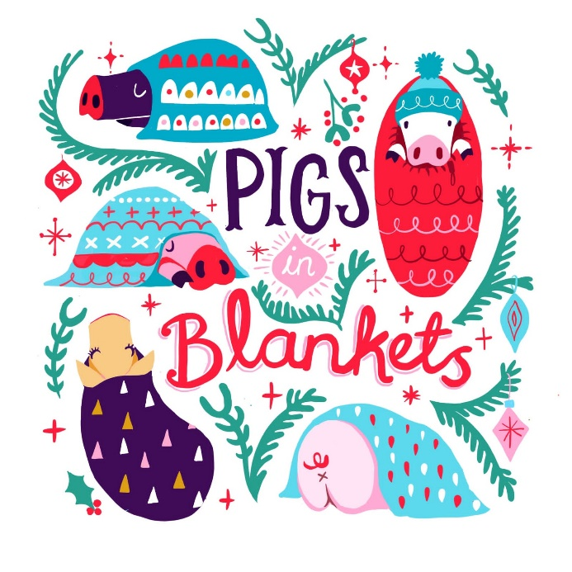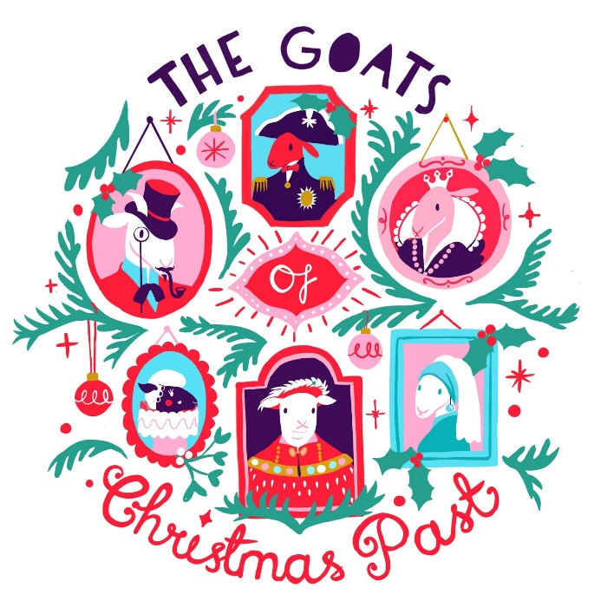
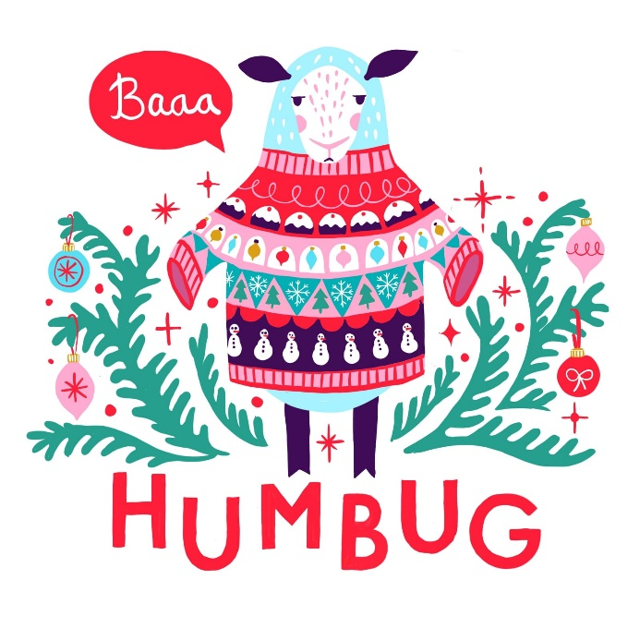
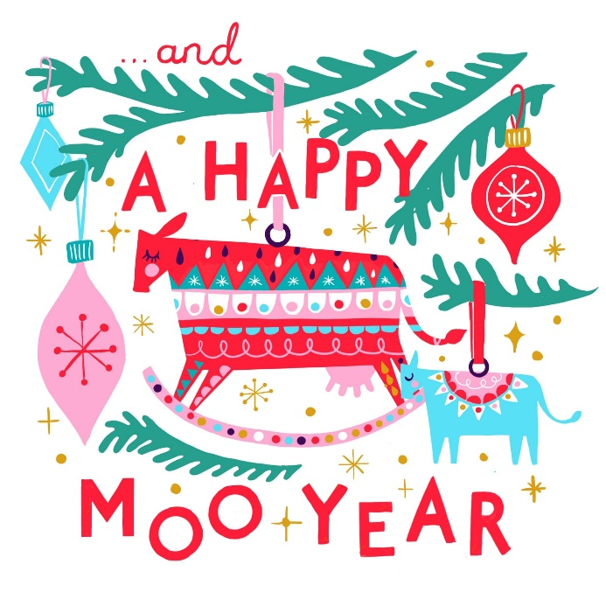
Design by Adelaide Leeder – GoodGood PrintShop

